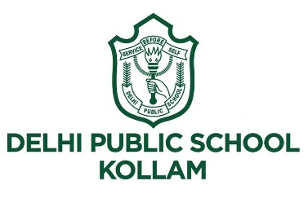

Dear Parents

Greetings from DPS Kollam!

“Once upon a time” - virtual reading rock star.
We are happy to share with you a unique event, which is being conceptualized and organized by Delhi Public school, Kollam to promote the love for books and reading in children. With our unique focus on English literature development as a part of our school curriculum, this event will give our children a broader platform to hone and showcase their language and literature skills.
“Once upon a time” virtual reading rock star, is a reading competition.
The competition is open to all students of Class I – IV

Date
Friday 18 June 2021

Theme
Spice of life

Time limit
Max 1 minutes (including introduction)

The last date to send your consent form for participation is on or before 14.06.2021.
Please click the link to open the consent form.

https://forms.gle/wNbDKBbvCBoSPjc1A

Rules and Regulations:

- Participants are to read aloud a small English story (Of your choice).
- Participants should adhere to the time limit and theme.
- Participants should report to their respective ID for the competition on time.

Judging criteria includes:

Picking an engaging story with a beginning, middle and end.
Usage of good voice modulation, enunciation, and expression.
Appropriate gestures and body language.
The winners of the competition will be awarded E-certificates.
Expecting active participation as we celebrate reading, a passport to countless adventures.

Regards
Principal
DPS Kollam

